***Coastal America Foundation***

*100 Muron Avenue*

*Bellingham, MA 02019*

*(508) 292-0251*

*http://www.CoastalAmericaFoundation.org*



**_______________________________________________________________________**

***Temperature and Benthic Studies in Buzzards Bay, Massachusetts***

The 1955 Buzzards Bay stations sampled by Howard Sanders (Sanders, 1958) are being re-occupied by the Coastal America Foundation to examine changes in benthic community structure. The original stations are being re-sampled with triplicate Van Veen grabs and a grain size analysis. Additionally, the Foundation continues to occupy 5 stations with temperature data loggers to track summer temperature maximums in upper Buzzards Bay. The temperature of Buzzards Bay has generally increased, resulting in lobster migration to cooler waters in summer.

**Ecological Issues:**

The warming of southeastern New England waters, especially in Buzzards Bay has produced several affects in biological communities. The harvest of lobsters experiences lows in the warmer summer months. The long term benthic community structure may be stable, but those motile species such as lobsters are migrating into cooler waters of higher dissolved oxygen. This temporal event has prompted public hearings (NEFMS, 2010) and speculation by the Massachusetts Division of Marine Fisheries (DMF, 2010) that drastic harvest restriction in Buzzards Bay and Southern New England may be necessary. Eutrophication in Buzzards Bay in conjunction with population increases along the coast has been well documented by the EPA Buzzards Bay National Estuary Program (Buzzards Bay CCMP, 2013). Comprehensive benthic community studies of Buzzards Bay have not been conducted in over 50 years and long term benthic temperature data is scarce.

**Materials and Methods**

The 1955 Sanders Buzzards Bay benthic community structure stations (Figure 1) are being re-sampled with a 0.04 meter square Van Veen Grab during 2011 to 2015. Other shallow benthic stations will also be occupied for community comparison. Five temperature and water quality stations are established with Onset data loggers for Temperature (to 0.01 C) in upper Buzzards Bay from mid- May through mid-October (Figure 2).

During 2010 researchers from the Coastal America Foundation obtained the raw data records with the support of the Woods Hole Oceanographic Institute library team (WHOI records, 1956). The original benthic sampling stations are being resampled starting in the fall of 2011 to mimic the original October sampling cruises of Howard Sanders. The original 1955 sampler was a modified Forster anchor dredge. The 2011 - 2015 sampling is being conducted with a VanVeen grab for better spatial accuracy and a slightly deeper penetration. Both were processed with a 500 micron sieve.

Each benthic community structure station will be sampled with 5 replicates using a 1/25 square meter Van Veen grab. Samples will be screened through a 0.5 micron sieve and preserved in formalin with a rose Bengal vital stain. Sorted samples will be identified to species. Benthic species dominance will be compared between the 1956 and 2011 samples (e.g. Bray-Curtis PRIMER v6).

Temperature is being sampled every 15 minutes at 0.5 meters above the sediment at 5 stations in upper Buzzards Bay. Each station has paired deployments of Onset Model U26-001 data loggers. The loggers will record from mid-May through mid-October to document the temperature rise and subsidence. The HOBO Water Temp Pro v2 has a sensor precision for ±0.2°C accuracy.

It is assumed that dissolved oxygen will be saturated and related to temperature. Data loggers in 2013 and 2014 will take dissolve oxygen at the benthic boundary layer every 15 minutes during summer. Monthly dissolved oxygen, temperature and salinity profiles will also be taken with an YSI-85 Meter. Occasional water grabs will be taken at surface, mid depth and bottom for pH analysis with a Milwaukee MW102 pH/Temperature meter. Hach Nitrate and Phosphate data will be measured. Secchi depth is also being recorded.

**Results Anticipated**

Benthic species dominance will be compared between the 1956 and 2011-2015 samples. Temperature results will be compared to all existing data discernable for detection of any trends, with a goal of establishing a 5 year benchmark of temperature at the benthic boundary layer.

Hard science will be available to increase public awareness of impending climate change adaptation needs.

**References**

Buzzards Bay Comprehensive Conservation and Management Plan, 2013. EPA Buzzards Bay National Estuary Program. {http://buzzardsbay.org/newccmp.htm}.

DMF, 2010 – Division of Marine Fisheries News, Massachusetts Division of Marine Fisheries, Volume 3: 4th Quarter 2010.

NEFMS, 2010 – New England Fisheries Management Council, Public Hearings on propose lobster management in southern New England.

"Papers of Howard L. Sanders, 1956-1996. MC-42, "Buzzards Bay, 1956." Data Library and Archives, Woods Hole Oceanographic Institution – {file:///C:/eadcb/EADFiles/completed%20EAD/MC-42brief_Sanders.html}.

Saunders 1958 – Benthic Studies in Buzzards Bay: I. Animal-Sediment Relationships, Howard L. Sanders, Limnology and Oceanography; Volume III, No. 3 - 1958.

Contact:

William A. Hubbard

[BillHubbard@CoastalAmericaFoundation.org](mailto:BillHubbard@CoastalAmericaFoundation.org)

(508) 292-0251

Figure 1: Sanders 1955 Stations in Buzzards Bay, Massachusetts

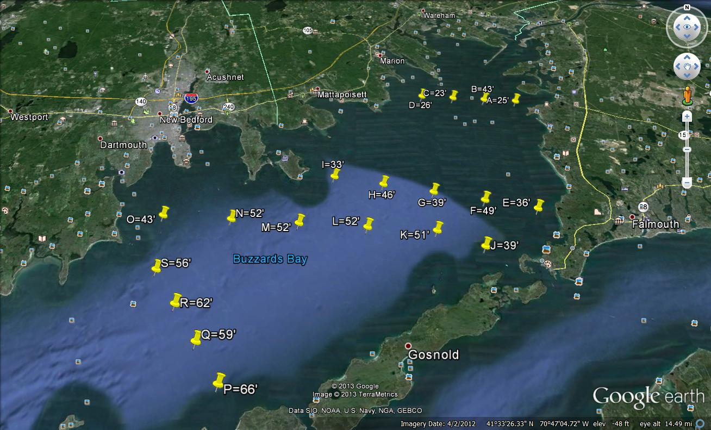

Figure 2: Coastal America Foundation Water Quality Stations in Buzzards Bay, Massachusetts

